EXPERIMENT RESULTS

- Quantitative Results
With Masking Sensitivity (dB) = 0
Audio | Removed Frequencies (%) | SNR (dB)
orchestral.wav | 52.74 | 1.11
pianosolo.wav | 60.28 | 2.3
tuneup.wav | 98.99 | 2.92
whitenoise.wav | 37.82 | 0.32

With Masking Sensitivity (dB) = -20
Audio | Removed Frequencies (%) | SNR (dB)
orchestral.wav | 7.07 | 1.15
pianosolo.wav | 16.25 | 2.37
tuneup.wav | 46.82 | 5.85
whitenoise.wav | 7.92 | 0.34

With Masking Sensitivity (dB) = -40
Audio | Removed Frequencies (%) | SNR (dB)
orchestral.wav | 3.89 | 1.16
pianosolo.wav | 3.82 | 2.58
tuneup.wav | 7.41 | 6.15
whitenoise.wav | 4.02 | 0.34

II. Qualitative Results
1. Listening Comparison
The subjective listening tests reveal a non-linear relationship between the sensitivity threshold and audio quality. The perceptual experience is categorized into three distinct zones:
The Transparency Plateau (-40 dB to -20 dB): In this range, the audio quality remains remarkably stable. There is minimal audible difference between -40 dB and -20 dB, as the algorithm primarily targets low-energy background noise and "invisible" frequencies. However, while high-fidelity is maintained, the audio at -40 dB still exhibits a subtle difference from the original, indicating that even minimal frequency removal (3-4%) affects the absolute "air" and texture of the sound.
The Perceptual Tipping Point (-20 dB to 0 dB): This is the range of maximum audible change. As the threshold moves toward 0 dB, the quality degrades rapidly. The "Balanced" setting at -20 dB serves as the "Sweet Spot," but moving closer to 0 dB introduces significant "hollow" artifacts and a loss of clarity. This aligns with the data showing the compression ratio jumping from 16% to over 60% in this narrow window.
The Residual Sound Analysis: By monitoring the "Removed Sound (Residual)" player, the difference between these levels is clarified. At -40 dB, the residual sound consists only of high-frequency hiss. At 0 dB, the residual player contains recognizable fragments of the original music or voice, confirming that the algorithm has begun discarding essential auditory information.
2. Visualizations (With Masking Sensitivity (dB) = -20)
orchestral.wav
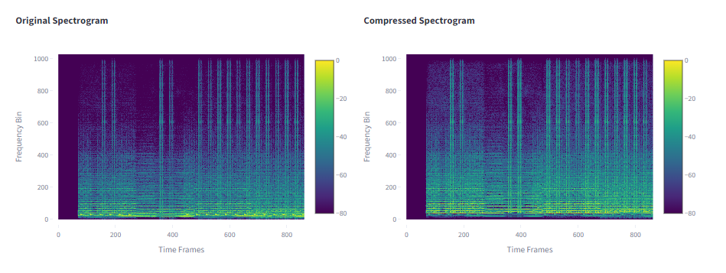
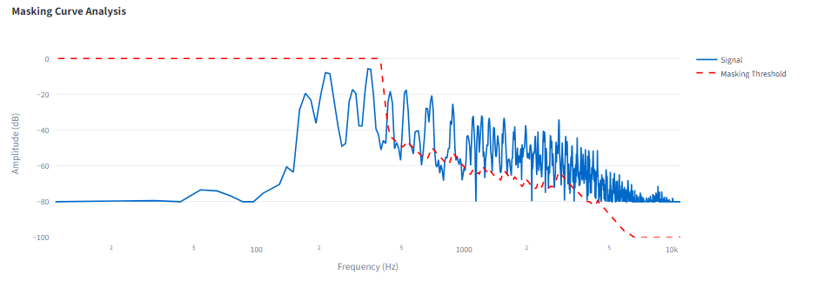
pianosolo.wav
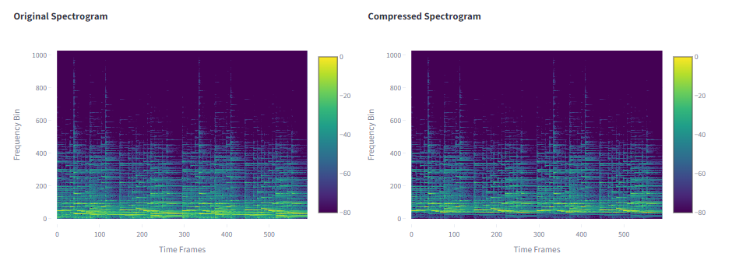
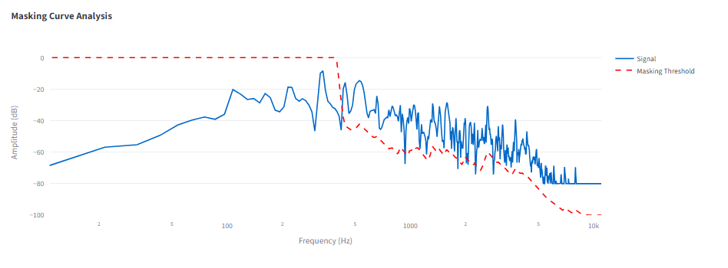

tuneup.wav
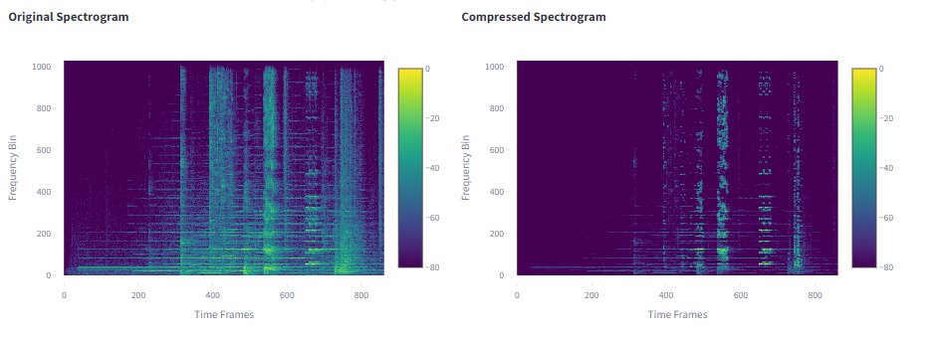
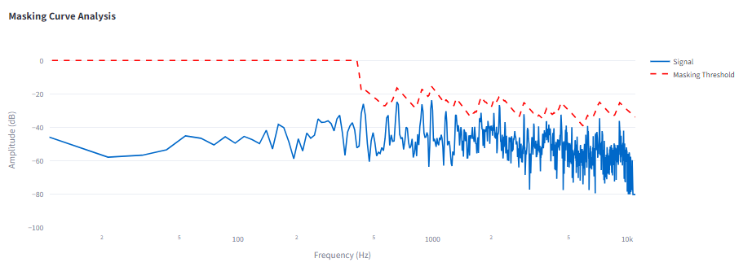
whitenoise.wav
